YOU COUNT!
Did your vote count on November 3, 2020?

RESTORE Election Integrity
An Evening with
Dr. Douglas Frank, PhD Thursday, August 26th 7:00 PM
Limited seating. Arrive no later than 6:30.

Life Church: Noblesville Campus
2200 Sheridan Road I Noblesville, IN. 46062
Cost: FREE
Donations will be accepted. Check or cash only

Dr. Douglas Frank holds a Ph.D in Surface Analytical Chemistry from the University of Cincinnati. Dr. Frank is an internationally recognized scientist with over fifty scientific publications.
Dr. Frank has spent countless hours since the 2020 elections following the data of the election returns county by county across such states as Ohio, Pennsylvania, and Colorado to name a few. His scientific and mathematical investigation has revealed that there was massive cyber fraud in the 2020 elections. Dr. Frank's investigation reveals that the 2010 national census data was used to pre-set the algorithms in the voting machines.
Tonight Dr. Frank will clarify and integrate his information in relationship to Mike Lindell's cyber attack documentation as well as several other key pieces of information.
This is a non-partisan group of patriots sharing key information on the Indiana election. The eye-opening information will be shared with you in several documents given to the attendees.

Presented by: Save Indiana

All of us have had an unsettled spirit since the 2020 election. Tonight passive Christianity has been set aside for the benefit of our society and each other.

Lady Draza
So, are there a lot of golf courses in Indiana? I am only wondering because their voting trends seem to indicate that they are the "Land of the Mulligans". Apparently, the trends were NOT going per the overall plan and they had to be restarted - A LOT. The restart shape is that drop - shark tooth - flat spot and then a rise. I see this shape feature over and over and over again. The height of the feature gets smaller as the total number of votes increases and the percentage that is modulated to produce the effect is a smaller and smaller percentage of the overall total...but they had to be restarted so many times!
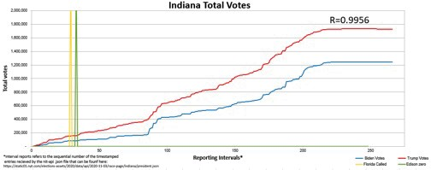

I don't know if it is because of all the restarts causing the shape of the Trump and the Biden total votes curves to be so very similar, but they have a very high correlation to one another.
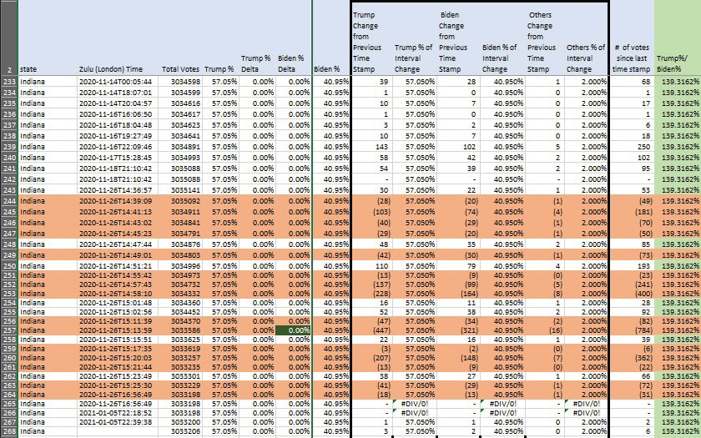
Now when you do that much monkeying around, you are going to have quite a mess to clean up - and they did! So many lines where the totals are being reduced! Notice that 34 of the lines shown here have the candidates receiving the EXACT same percentage of the interval votes as they currently had of the overall vote - even the 15 updates that reduce the overall total votes.
Sharing is caring in Indiana...apparently.

O CTOB ER 1 6 , 20 20 :JUDICIAL WATCH

New Judicial Watch Study Finds 353 U.S. Counties in

·29

States with Voter Registration Rates Exceeding 100%
1.8 /'Vlillion 'Extra' Registered Voters
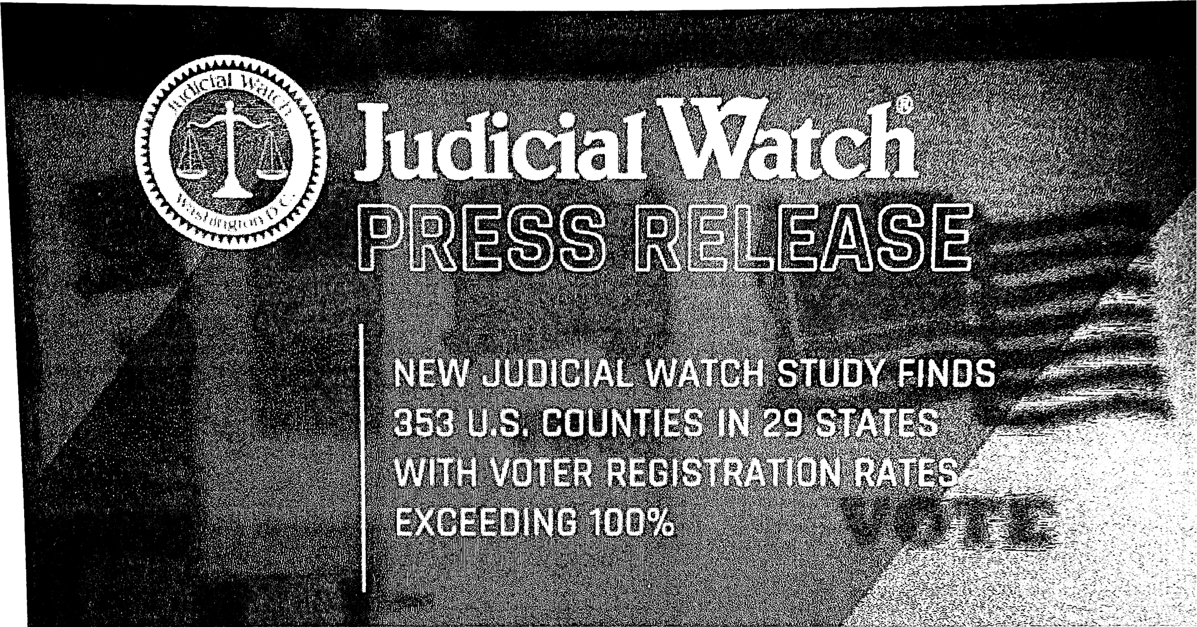

(Washington, DC) - Judicial Watch announced today that a September 2020
study revealed that 353 U.S. counties had 1.8 million more registered voters than eligible voting -a ge citizens. In other words, the registration rates of those counties exceeded 100% of eligible voter s.

Judicial Watch Attorney Robert Popper is the director of Judicial Watch's clean elections init iative.

*Indiana:
Hamilton County (113%);
Boone County (112%);
Clark County (105%);
Floyd County (103%);
Hancock County (103%);
Ohio ounty (102%);
Hendricks County (102%);
Lake County (101%);
Warrick County (100%);
Dearb.orn County (100%)

20 20 Election Fraud Benefiting Biden Occurred verywhere- Even Hamilton County Indiana Reported Impossible Results
By Jim Hoft
Published December 14, 2020 at 11:30am . ·

The 2020 election was the most corrupt and compromised election m US h•s!ory.
Old D m crat methods of voting for dead people merged with mode n machme machmat,ons. The result was the greatest election win in history bemg st 0e1 n by both US and foreign actors.

Up until 2020, no Presidential candidate had broken 70 million votes in an elect io n. Barack Obama had reached a reported 69 million in 2008 but that was the record, until this year. Then President Trump smashed the record and won an unheard of 74 million votes. This was a record for any candidate and certainly for a sitting President.

Despite liberal garbage polls telling us otherwise, President Trump's vote accumulation was not surprising. He had tens of millions following him on social media and over a million at his rallies the last two months of the elect ion . Car parades, boat parades, signage, and more were like never seen befo re.

Then Joe Biden stole the election. The man who couldn't get five people at a rally did the impossible and won over 80 million votes!

This did not happen. This was impossible. The Democrats, China, and world elites all hated President Trump and they did all they could to stop him.

We've provided ample evidence of fraud around the country, especially in the swing stat es . But we even have evidence of fraud in solidly red states.

Below is a study of one county in Indiana - Hamilton County - performed by an expert and reader at the Gateway Pundit. The first observation of the study was that more people were on the voter roll in Hamilton County than there are eligible voters in the county.

Hamilton County, Indiana
2020
Hamilton County, Indiana
2020 | ElectionDay | EarlyVoting | Absentee |  | Total | Overall
Trump | 34,747 | 49,617 | 17, 223 |  | 101,587 | 52%
Biden | 16,074 | 46,520 | 25,796 |  | 88,390 | 45%
Jorgensen( L) | 1 , 643 | 1,472 | 779 |  | 3,894 | 2%
Writeln | 286 | 293 | 127 |  | 706 | 0"/4
 | 52,750 | 97,902 | 43,925 |  | 194,577 | 100"/4
2016
Trump | 59,199 | 22,068 | 6,032 |  | 87,299 | 56%
Clinton | 35,211 | 17,472 | 4,531 |  | 57,214 | 37%
Johnson(L) | 6,9 21 | 1,616 | 580 |  | 9,117 | 6%
Writeln | 1,634 | 426 | 109 |  | 2,169 | 1%
 | 10 2,965 | 41,582 | 11, 252 |  | 155,799 | 100"/4
Change '16-'20 | -50,215 | 56,320 | 32,673 |  | 38,778
 |  |  |  | Trump | 14,288
 |  |  |  | Bi den | 31,176

Registered | Voters | 2020 | Est County Population | 18 | + | Voters/ Population
260,082 | 252,565 |  |  | 103%

Another significant point is that the increase in voters from 2016 was in absentee ballots.

Hamilton County 2020 General Election Results
11/13/2020 - 11:47:16 AM

Note: These are the Official final results.

11/13/2020 · 11:47:16 AM
Election Date: 11/3/2020 Election Summary Report
Hamilton County, Indiana 2020 General Election INHAMG20
11/3/2020

Field

EMS

E- # OFElec tion Day

A- # OF Paper Absentee

53147
44376

Nm -IBER OF PRECil'iCT, S # OF PRECINCTS REPORTE,D

221
221

W- # OF W alk-In Absentee
98465

PUBIJ CCOUlff , 19 5988
# or PRECINCTS NOTREPORTED, o
# or PRECTh"CTS L'iCm •!PLETE, O

VOn:R TUR'iOUT, 75.36% REGISTERED VOT ERS, 260082
- - - - - - - - - - - - - - - - - - VOTE S - - - - - - - - - - - - - - - -
# OF EQlilPMENT PROGRAM\. IE,D # or EQUIP IE.NT REPORTE,D
665

6 65

 | A | w | TOTAL
 |  |  |  |  | VOTE FOR 1
 | VOTE S= | 19 4,577 |  |  | President and VP of the U.S. (Click for Precinct
34747 | 17223 | 49617 | 101587 | 52.21% | (R) Trump \ Pence
16074 |  | 46520 | 88390 | 45.43% | (D) Biden \ Harris
1643 |  | 1472 | 3894 | 2.00% | (L ) Jorgen sen \ Coh en
286 | 127 | 293 | 706 | 0.36% | Write-In
 |  |  |  |  | VOTE FOR 1
 | VOTE S= | 1 93,584 |  |  | Governor and Lt Governor (Click for Precinct
34623 |  | 58028 | 117749 | 60.83% | (R) Holcomb \ Crouch
9941 | 17003 | 31770 | 58714 | 30.33% | (D) Myers \ Lawson
7991 | 1333 | 7797 | 17121 | 8.84% | (L) Rainwater II \ H enry
 |  |  |  |  | VOTE FOR 1
 | VOTE S= | 187,347 |  |  | Attorney General {Click for Precinct Breakdown.. .)
35518 | 20758 | 53522 | 109798 | 58.61 % | (R) Todd Rokita
14924 | 21889 | 40736 | 77549 | 41.39% | (D) Jonathan Weinz.apfel
 |  |  |  |  | VOTE FOR 1
 | VOTE S= | 19 2,585 |  |  | U.S. Rep District 5 {Click for Precinct Breakdown... )

c:nrn::,
34706 | 18251 | 50596 | 103553 | 53.77% | (R) Victoria Spartz Note : Spartz only wo n S
14875 |  | 43946 | 82512 | 42.84% | (D) Christina Hale
2653 | 1217 | 2601 | 6471 | 3.36% | (L) Kenneth Tucker also part of t his d ist rict.
28 | 7 | 14 | 49 | 0.03% | Write-In

O% to 46 % w hen including the part of Marion County which is

This one block of absentee ballots showed abnormal results. This block voted for Biden, the Republican Governor, and the Democrat House candidate. What was going on?

Open Door Law
You have the right to attend certain government meetings

The Open Door Law, also known as Indiana Code 5-14-1.5-1, states that government agencies must hold oficial meetings of a majority of their governing body, such as council or board meetings, publicly. As a citizen, you have the right to attend and record these meetings.
Office of Corporation Counsel
 317.327.4055

While you can attend or record these events, you do not have the right to speak at them. You may have the opportunity to
speak if meeting officials allow members of the public to speak.

Public meetings must be in rooms and buildings that people with disabilities can access.

For detailed information on the Open Door Law, you can review the Handbook on Indiana’s Public Access Laws.

Executive sessions
Under the Open Door Law, some meetings are closed to the public. Meetings closed to the public are called executive sessions. Executive sessions generally fall into one of these categories:
 8 a.m.-5 p.m. (M-F)

 City-County Building 200 E. Washington St.
Suite 1601
Indianapolis, IN 46204

Discussion of collective bargaining, litigation, or security system strategies Session to receive information about and interview prospective employees Discussion of records classified as confidential by state or federal law
Discussion of job performance or discipline of individual employees When an agency holds an executive session, any vote on a motion, proposal, resolution, or ordinance must take place in a public meeting. The state does not allow secret ballots.

Public notice, memoranda, and minutes

Agencies must give public notice of any public meeting or executive session at least 48 hours in advance. The notice must include the date, time, and location of the meeting or session.
The agency must post the notice on the outside of its main office or at the meeting location. It must send notices to any media that asked by January 1 of the current year to receive them.

The 48-hour notice period does not include Saturdays, Sundays, or legal holidays. The notice for an executive session must state the specific part of the Open Door Law that allows it to be a private meeting. Agencies must keep memoranda of each public meeting and make them available to you for inspection and copying within a reasonable time after the meeting.
Memoranda generally include:

Date, time, and place of the meeting Members present or absent
General information on matters discussed or decided
Record of votes taken, listed by individual if a roll call vote was taken Agencies must also make any minutes taken available to you for inspection and copying. The minutes and memoranda for executive sessions must identify the specific part of the Open Door Law that allowed it to be a private meeting. They must also state that no other matters were discussed during the session.

Violation of Open Door Law

If you were not allowed to attend a public meeting or are not sure if a meeting violated the Open Door Law, contact your attorney, the state public access counselor, or the city-county public access counselor. You may receive attorney’s fees if you contact the state public access counselor first. You can reach the state public access counselor at 317.233.9435 or 1.800.228.6013.
If a meeting has violated the Open Door Law, the court can choose to stop or make void any action taken during the meeting, or make a formal statement that the meeting violated the law.

